From the Director, U.S. Life Master Lou Mercuri

After many years of working successfully with chess students on an individual or group basis, I am committed to continuing a training program for young players that will provide an environment conducive to growth and improvement in chess. The emphasis is on specific improvement and feedback for each player, to give every player a chance to grow and improve in chess. Our players continue to learn, develop, and compete successfully for state and national scholastic championships. We continue to offer new training sessions, materials, and topics for each of the weeks.
The summer 2012 program will feature our fourth year at the recently renovated and updated Brigham House. Not only is the facility more spacious, we have more onsite amenities at our disposal and I thank the Brigham House directors for allowing us to continue to use this great site!
For the past 6 years, both summer sessions were completely filled. Please consider registering prior to June 1 to ensure a spot for your son or daughter.
Please feel free to contact me at (508) 373-1375, or at loumercuri2@aol.com for further information about the program.
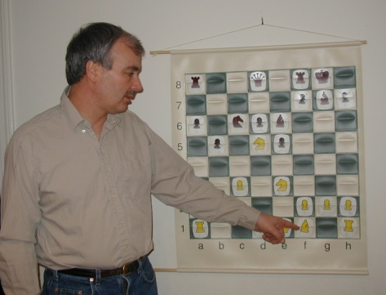
Program Details
When
Session I: June 25 – June 29, 2012
9:00 AM to 3:45 PM
Session II: August 6 – 10, 2012
9:00 AM to 3:45 PM
Lunches from Bread and Chocolate will be available for an extra charge, if requested in advance. Please indicate your interest on the registration form.
Where
Brigham House, 20 Hartford Street,
Newton Highlands, MA
The site is located in the Newton Highlands Village Center, just 5 minutes from Route 95/128 and is nearly adjacent to Route 9. MBTA Green Line service is nearby. The site is handicapped-accessible.
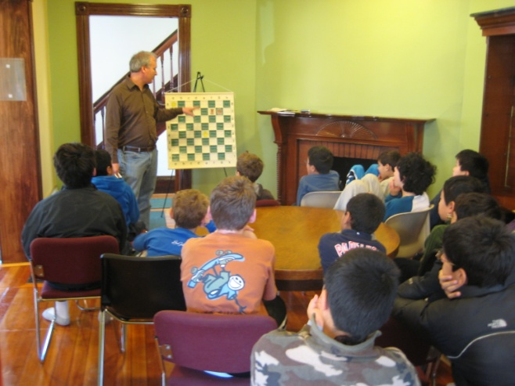
Comfortable surroundings include pool table, large screen television for chess videos, and table tennis. Optional activities include use of nearby basketball courts and City of Newton Crystal Lake swimming facility.
Registration Form
Name__________________________________
Address________________________________
City____________State______Zip Code______
Home Phone____________________________
Age and Grade __________________________
US Chess Rating_________________________
Email Address___________________________
Parent/Guardian_________________________
Daytime Phone__________________________
Emergency Contact Information
Name__________________________________
Relationship_____________________________
Phone (home/cell)_______________________
Tuition
- Session I $335 June 25-June 29, 2012
- Session II $335 August 6-10, 2012
- Both sessions: $295 per week
- Two or more members from same family in same week: $295 per student
Tuition Enclosed:_________________________
A nonrefundable deposit of $125 is due at registration, and will be applied toward tuition. Payment in full is due on or before June 15.
Are you interested in the daily lunch from Bread and Chocolate? (details to follow) Yes No
Are you interested in being contacted regarding carpooling? Yes No
Please make checks payable to:
Louis Mercuri
502 South Avenue
Weston, MA 02493
(781) 373-1375
loumercuri2@aol.com
About the Director
NM Lou Mercuri
- USCF Rating 2375 and U.S. Life Master (Highest rating achieved: 2404/Senior Master)
- Defeated World Champion Anatoly Karpov in exhibition play in 1990
- Awarded International title of FIDE Trainer at Turin Olympics in May 2006 (awarded to certified trainers rated over 2300)
- Coached numerous Massachusetts players and teams at National Scholastic Championships in Orlando, Pittsburgh, Chicago, Nashville, Louisville, Atlanta, and Dallas
- Teaches scholastic chess programs in Acton, Wellesley, Shrewsbury, Weston, Sudbury, Framingham, Concord, and Southborough
- Students have won State Scholastic Singles Championships and a National Championship
- Writer and publisher of theoretical opening articles, chess publications, and reviewer for Chess Horizons


Special Features
- Small group training sessions
- Tournament preparation
- How to get an advantageous middle game out of the opening
- Building an opening repertoire
- Book prizes
- Daily competition / Blitz chess tournament
- Group analysis of students’ best games
- New training manuals for each session
What Parents and Students Have To Say
Since moving to Massachusetts three years ago, my kids have not missed a single week of Lou’s Summer All Star Chess program. It’s Jacob, Charlie, and Alex’s favorite summer camp experience. They love the tournaments, blitz chess, and swimming at Crystal Lake. Lou is a gifted coach who helps each child discover and develop their individual chess playing style.
Eric Fauman, parent of Jacob, Charlie, Alex, and Ben Fauman
Lou’s chess camp helped Max build up a solid basis in chess and paved the way for him to go even further in his chess journey. For the past three years, Max went to the camp every summer and improved dramatically. I cannot thank Lou enough!
Gina Chang, parent of Max Lu
Lou has been a great coach for our son. He knows how to develop him into a competitive player while nurturing his love of chess and the shared camaraderie with the friends he's made.
Paula Russo Woodman, parent of Nicholas Woodman
My son Jordan has attended both of Lou’s summer and winter chess camps a number of times over the last few years. He always has a terrific time making new friends and reconnecting with old friends. The camp structure provides a combination of instruction, competitive games and fun activities such as basketball and swimming. Jordan’s chess continues to improve and Lou has been instrumental in his journey!
Susan Shapiro, parent of Jordan Shapiro
I liked the chess camp because you got to play against a lot of people. We went swimming and played blitz and it’s really fun.
Michelle Chen
I liked the way you organized the program. You provided training materials at the beginning and an evaluation letter at the end. So while you had fun in playing, you also knew your weak and strong parts and got a list of references on how to improve your skills.
Billian Li, parent of Michelle Chen
Evan has thoroughly enjoyed Lou's chess camps, having attended the last four offered. It is a great opportunity for kids to get the experience of competitive play without the stress that comes with an actual tournament, and Lou does a great job of assessing the students' strengths and weaknesses and tailoring instruction to all levels. I was quite impressed with how much Evan improved over each session and certainly plan to send him again this summer.
Eric Meyer, parent of Evan Meyer
U.S. Life Master and FIDE Trainer

Lou Mercuri’s
11th Annual Summer
All Star
Chess Training School

2012

For Serious Young Chess Players Between the Ages of 8 and 16 Who Want to Make Considerable Progress in Improving the Focus of Their Game
Session I: June 25-June 29, 2012
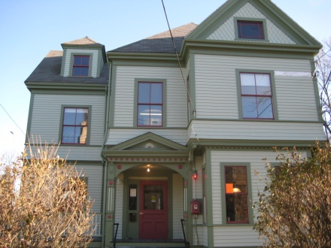
Session II: August 6-10, 2012
Sessions held at the recently renovated Brigham House
20 Hartford Street
Newton Highlands, MA
Easy to reach from I-95/128
Program made possible by the
Brigham Community House Organization

